**Pipe and Redirection Operators**

1. Create a script named “myscript” in current directory to do the following.

* To create a script named “myscript” in current directory use “vim” command.



1. create a dir named “subd1” in current directory

* To create a directory named as subd1in current directory, the command “mkdir subd1” is used.



b) create a file named “dircontent” with contents of the current directory

* To create a file named dircontent with contents of the current directory “ls > dircontent”.



1. display the contents of the file “dircontent”.

To display the contents of the file dircontent, the command “cat dircontent”.

e) display the contents of a non existing file named “unknownfile”.

To display the contents of a non existing file named unknowfile, the command “cat unknownfile”.



1. Run the script and validate the output in following cases
2. Redirect only the stdout to an o/p file named stdout.txt

This command runs scripts.sh and redirects its standard output (stdout)“./scripts.sh > stdout.txt”

b) Redirect only the stderr to an o/p file named stderr.txt

This command runs scripts.sh and redirects its standard error (stderr)“./scripts.sh2 > stderr.txt”

c) Redirect both stdout and stderr to an o/p file named stdall.txt

This command runs scripts.sh and redirects both standard output (stdout) and standard error (stderr)“./scripts.sh > stdall.txt 2 > &1”

d) Display all o/p and error and also redirect both stdout and stderr to an o/p file named stdall.txt

This command runs scripts.sh and the output (stdout) is piped to the tee command, tee displays the output in the terminal while simultaneously writing it to stdall.txt.

./scripts.sh |& tee stdall.txt

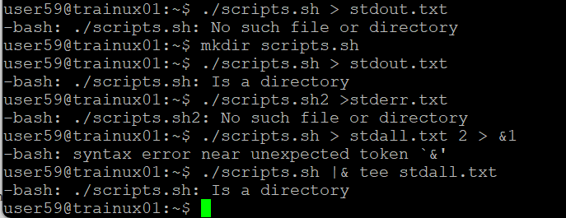

3. Redirect the output of command below using pipe (|) to wc and get the output.

To redirect the output of command to wc using a pipe (|), typically the syntax <command> |wc <option>

-l for number of lines

-w for number of words

-c for number of characters

